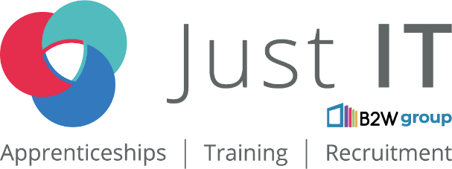

**Data Technician**

|  |
| --- |
|  |

|  |
| --- |
| Name: |
| Course Date: |
|  |

**Table of contents**

Day 1: Task 1 3

Day 1: Task 2 3

Day 1: Task 3 4

Day 2: Task 1 5

Day 3: Task 1 9

Day 3: Task 2 10

Day 3: Task 3 11

Day 4: Task 1 12

Day 4: Task 2 13

1. Scenario Background 13

2. Data Laws and Regulations 14

3. Azure Service Recommendations 14

4. Data Types and Data Modelling 14

5. Data Storage Formats and Structures in Azure 14

6. Additional Considerations 15

Submission Guidelines: 15

Course Notes 17

Additional Information 17

# Day 1: Task 1

Please research and complete the below questions relating to key concepts of cloud.

Be prepared to discuss the below in the group following this task.

|  |  |
| --- | --- |
| What can cloud computing do for us in the real-world? | Gives us data storage and accessibility, facilitates remote work and team work, helps businesses to scale up. |
| How can it benefit a business? | Removes server maintenance costs, helps in case of a failure with cloud backups, reduces costs with not having to have a physical server/data centre on premise,  Access to cutting-edge tech, that otherwise a business might not be able to get, security. |
| What’s the alternative to cloud computing? | Hosting, or on-premise servers/data centres or a mix of on premise and some cloud services |
| What cloud providers can we use, what are their features and functions? | **AWS** –  Compute Power: Amazon EC2 (virtual machines), AWS Lambda (serverless computing).  Storage: S3 (scalable object storage), EBS (block storage for virtual machines).  AI & Machine Learning: Amazon SageMaker (build and deploy AI models).  Database Services: RDS (relational databases), DynamoDB (NoSQL).  Security & Compliance: Identity and Access Management (IAM), encryption, and global compliance standards.  Scalability: Auto-scaling and Elastic Load Balancing for dynamic workloads.  **Microsoft Azure –**  Compute Power: Azure Virtual Machines (VMs), Azure Kubernetes Service (AKS).  Storage: Azure Blob Storage (unstructured data), Azure Files (file shares).  AI & Analytics: Azure AI (cognitive services) and Azure Synapse (data analytics).  Hybrid Solutions: Azure Arc enables integration between on-premises and the cloud.  Security: Azure Active Directory (identity management) and built-in compliance.  Integration: Seamless with Microsoft products (Office 365, SQL Server).  **Google Cloud Platform (GCP) –**  Compute Power: Google Compute Engine (VMs), Google Kubernetes Engine (GKE).  Storage: Google Cloud Storage (object storage), Persistent Disk (block storage).  AI & Data: Vertex AI (machine learning platform) and BigQuery (data analytics).  Networking: Global load balancing and content delivery network (CDN).  Security: Zero Trust model, encryption by default, and compliance certifications.  Open Source Support: Extensive support for open-source and multi-cloud environments.  **Oracle Cloud Infrastructure (OCI) –**  Compute Power: Virtual machines and bare-metal instances.  Database Services: Oracle Autonomous Database and MySQL HeatWave.  Security: Identity and security automation, data encryption.  Enterprise Focus: Optimized for Oracle applications (ERP, HR, and CRM).  Hybrid & Multi-Cloud: Interoperability with other cloud providers.  **IBM Cloud –**  Compute Power: Virtual servers, containers, and bare-metal servers.  AI & Analytics: IBM Watson for AI services and predictive analytics.  Hybrid Cloud: Strong hybrid and multi-cloud management.  Security: High-level encryption and compliance across industries.  Blockchain: Blockchain-as-a-Service for secure transactions. |

# Day 1: Task 2

Please research the below cloud offerings, explain what they are and examples of use cases.

|  |  |  |
| --- | --- | --- |
| Cloud Offerings | Explain what it is | When / how might you use this service in the real-world? |
| IaaS (Infrastructure as a service) | IaaS is like renting virtual computers and storage from a cloud provider instead of owning and maintaining physical servers. You get the basic building blocks—things like virtual machines, storage, and networks—without worrying about the hardware. | Hosting a website or App: Instead of buying expensive servers, we can rent virtual ones to host a site or app.  Scaling Up or Down: If the business has busy seasons (like Black Friday for an online store), we can quickly add or reduce computing power as needed.  Testing New Software: Developers can quickly create virtual environments to test new apps without buying new hardware.  Backup & Recovery: Keep backups of the data in the cloud so we can restore it if something goes wrong.  Examples: Amazon EC2, Microsoft Azure Virtual Machines, Google Compute Engine |
| PaaS (Platform as a service) | PaaS is a ready-made environment for building and launching apps. It gives you everything you need—like servers, databases, and development tools—without managing the technical stuff behind the scenes. | Building Apps Fast: If developing an app, PaaS lets us focus on coding while the cloud provider handles the infrastructure.  Automating Software Updates: It’s great for automating updates, testing, and deploying new software features.  AI and IoT Projects: Perfect if we want to build smart apps (like AI or Internet of Things) without starting from scratch.  Internal Tools: Businesses use PaaS to create custom tools that streamline tasks (like tracking employee schedules).  Examples: Google App Engine, Microsoft Azure App Services, AWS Elastic Beanstalk |
| SaaS (Software as a service) | SaaS is software you access over the internet—no downloads or installations required. You just log in and use it. It’s like streaming movies but for work tools. | Email & Office Tools: For everyday tasks like sending emails, writing documents, and video calls.  Managing Customers: Businesses use SaaS platforms to track customer info and manage sales.  Collaborating with Teams: Sharing files and working together on documents in real time.  Accounting & HR: Handling payroll, track expenses, and manage employee records without needing complex software installations.  Examples: Google Workspace (Gmail, Docs), Microsoft 365, Salesforce, Dropbox |

# Day 1: Task 3

Please research the below terms and explain what they are, when they would be appropriate and a real-world example of where it could be implemented (i.e. what type of organisation).

|  |  |
| --- | --- |
| Public Cloud | What is it?  It’s a cloud service that’s open to anyone and run by third-party providers like Amazon Web Services (AWS), Microsoft Azure, or Google Cloud. We share the provider’s resources with other customers, but our data stays private.  When is it a good choice?  If we want to save money – No need to buy or maintain our own servers.  Need to scale quickly – Ideal for businesses that experience fluctuating traffic (e.g., an online store during holiday sales, or a streaming service when a new popular content is added).  For testing and development – Great for experimenting without investing in expensive hardware.  Example:  A startup launching a new mobile app could use AWS to host it. This way, they don’t have to buy expensive servers and can scale up if the app becomes popular, or down in slower months. |
| Private Cloud | What is it?  A private cloud is like having our own personal cloud environment. It’s dedicated to one organisation, offering greater control, customisation, and security. It can be hosted in our own data center or by a private cloud provider.  When is it a good choice?  If security is a top priority – Ideal for businesses handling sensitive information (e.g., health records or financial data).  Need full control – Useful when we want to customise everything, from hardware to software.  Follow regulations – Industries like healthcare and banking often need to meet strict privacy rules.  Example:  A bank might use a private cloud to securely store customer data and comply with financial regulations while maintaining total control over their systems. |
| Hybrid Cloud | What is it?  A hybrid cloud is a mix of public and private clouds. We can keep sensitive data in a private cloud while using the public cloud for other tasks. It’s the best of both worlds!  When is it a good choice?  If we need flexibility – Keep sensitive data private but use the public cloud for customer-facing services.  Want a backup plan – Use the public cloud for disaster recovery in case our private cloud goes down.  We’re already using both – Many companies blend public and private clouds to balance security and performance.  Example:  A hospital could store patient medical records in a secure private cloud but use a public cloud to run their patient scheduling system. |
| Community Cloud | What is it?  A community cloud is shared by several organisations with similar needs—like regulatory requirements or industry standards. It’s not open to the public but allows these organisations to collaborate securely.  When is it a good choice?  If multiple organisations share the same needs – Useful for industries like healthcare, education, or government.  Cost-sharing makes sense – Splitting costs among multiple organisations can save money.  Working on a joint project – Helpful for large-scale collaborations.  Example:  Several universities working on a shared research project could use a community cloud to store and analyse data while keeping it accessible and secure for all participants. |

# Day 2: Task 1

Describe, with examples, the **three** major areas that the Computer Misuse Act deals with.

|  |  |  |
| --- | --- | --- |
| Area | Description | Example |
| Unauthorised access to computer material | Accessing a computer system or data without permission. | Hacking into someone’s email account. |
| Unauthorised access with intent to commit or facilitate a crime | Accessing a system without permission to commit further offences. | Breaking into a system to steal personal data for fraud. |
| Unauthorised acts with intent to impair operation of a computer | Deliberately causing damage to data or disrupting system functions. | Spreading a virus to damage files or crash systems. |

The computer misuse act 1990 is an act where an individual can be criminalised because of computer related offense. Describe three extra powers that the Police and Justice Act 2006 (Computer Misuse) has added.

|  |
| --- |
| Description |
| Increased penalties for computer misuse:  The Police and Justice Act 2006 increased the maximum prison sentence for serious computer misuse offences from 5 years to 10 years, allowing harsher punishment for those committing severe cybercrimes. |
| Making denial-of-service (DoS) attacks illegal: The Act made it a criminal offence to carry out or attempt DoS or DDoS attacks, where someone deliberately overwhelms a system to make it unavailable to users. |
| Illegal creation or distribution of hacking tools: It also became illegal to create, own, or share software or tools intended to hack systems or help others commit computer-related crimes. |

Look at the below website to answer the questions:

<https://www.gov.uk/personal-data-my-employer-can-keep-about-me>

|  |
| --- |
| Write down three items of data which a company can store about an employee. |
| Name |
| Address |
| National Insurance Number |

|  |
| --- |
| Give three more examples of data that an employer can only store if they first get the employee’s permission. |
| Race and ethnicity |
| Trade union membership |
| Sexual history or orientation |

Conduct further research to answer the below questions.

|  |  |
| --- | --- |
| Question | Answer |
| Provide one example of: Copyright infringement | Downloading and sharing a movie or music album without permission from the creator or copyright owner. For instance, distributing a newly released film on a file-sharing website without the studio's approval violates copyright laws. |
| Provide one example of: Plagiarism | Copying text from an online article or academic paper and presenting it as your own work without giving credit to the original author. For instance, submitting a school essay that includes paragraphs directly taken from a website without citation is plagiarism. |
| What are two consequences of copyright infringement and software piracy? | **Legal Consequences**: Individuals or organisations involved in copyright infringement and software piracy can face serious legal actions, including lawsuits, fines, and penalties. Depending on the severity, they may be required to pay substantial damages to the copyright holders. In some cases, criminal charges can be brought, leading to imprisonment.  **Economic Losses**: Piracy and copyright infringement can result in significant financial losses for creators and companies, as they lose potential revenue from legitimate sales or licensing. This can hinder innovation and the ability to reinvest in further development, affecting the broader economy, especially for software developers and content creators who rely on income from their intellectual property. |
| Give three possible consequences for individuals when using pirated software | **Imprisonment:** For commercial-scale online copyright infringement, individuals can face up to 10 years in prison. This increase from the previous maximum of 2 years was proposed to align online infringement penalties with those for physical goods. ​[GOV.UK](https://www.gov.uk/government/news/online-criminals-set-to-face-tougher-penalties-for-copyright-theft?utm_source=chatgpt.com)  **Fines:** Offenders may be subject to fines up to £50,000. On summary conviction, the penalties can include imprisonment for a term not exceeding six months or a fine not exceeding £50,000, or both. ​[Mary Monson Solicitors](https://marymonson.co.uk/free-legal-advice/piracy-computer-fraud-solicitors/?utm_source=chatgpt.com)  **Damages and Legal Costs:** Copyright holders can pursue civil litigation against individuals using pirated software, seeking damages and reimbursement for legal expenses. |

Listed below are some laws which we have covered today:

1. Computer Misuse Act 1990

2. Police and Justice Act 2006 (Computer Misuse)

3. Copyright, Designs and Patents Act 1988

4. Copyright (Computer Programs) Regulations 1992

5. The Health and Safety (Display Screen Equipment) Regulations 1992

6. Data Protection Act 2018

7. Consumer Rights Act 2015

* Insert a number in the first column of each row to match each of the statements with one of the above Acts.
* One of statements is incorrect and not illegal. For this statement, write ‘Not illegal’.

|  |  |
| --- | --- |
| **Act number** | **Clause** |
| 3 | With some exceptions, it is illegal to use unlicensed software |
| 7 | Any product, digital or otherwise, must be fit for the purpose it is supplied for |
| 2 | Unauthorised modification of computer material is illegal |
| Not illegal | It is illegal to create or use a hacking tool for penetration testing |
| 6 | Personal data may only be used for specified, explicit purposes |
| 5 | Employers must provide their computer users with adequate health and safety training for any workstation they work at |
| 2 | It is illegal to distribute hacking tools for criminal purposes |
| 3 | It is illegal to distribute an illicit recording |
| 6 | Personal data may not be kept longer than necessary |
| 1 | Gaining unauthorised access to a computer system is illegal |
| 5 | Employers must ensure that employees take regular and adequate breaks from looking at their screens |
| 1 | It is illegal to prevent or hinder access (e.g. by a denial-of-service attack) to any program or data held in any computer |
| 6 | Personal data must be accurate and where necessary kept up to date |

# Day 3: Task 1

Please complete the below lab (3) *‘Explore relational data in Azure’* and paste evidence of the completed lab in the box provided.

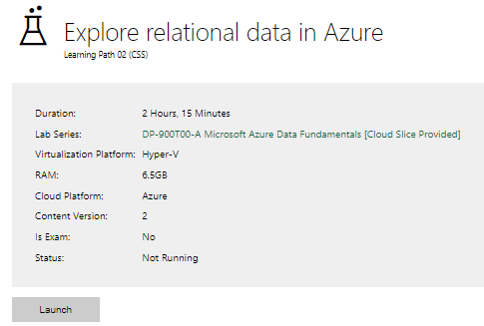

|  |  |
| --- | --- |
| Completed lab |  |

# Day 3: Task 2

Please complete the below lab (4) *‘Explore non-relational data in Azure’* and paste evidence of the completed lab in the box provided.

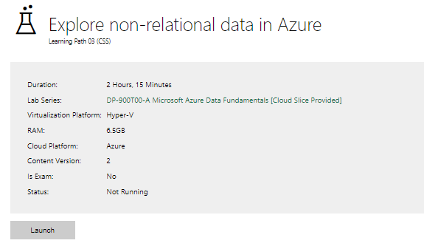

|  |  |
| --- | --- |
| Completed lab |  |

# Day 3: Task 3

Please complete the below lab (5) ‘Explore data analytics in Azure’ and paste evidence of the completed lab in the box provided.

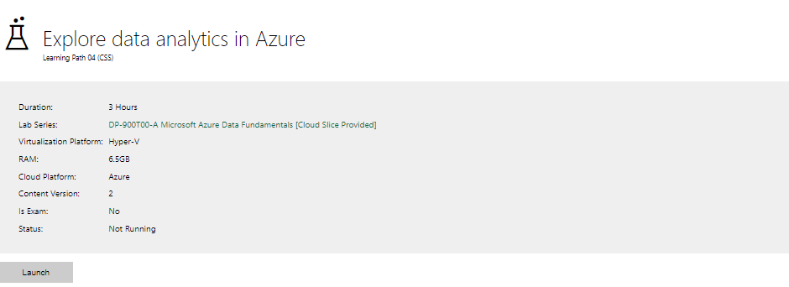

|  |  |
| --- | --- |
| Completed lab |  |

# Day 4: Task 1

In your teams, complete the Azure DP-900 practice exam and paste your result below – this is open book and please research and discuss your answers as a team.

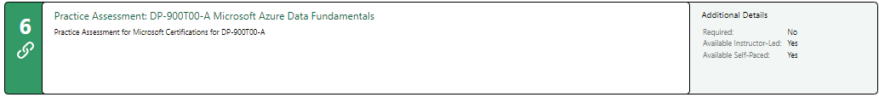

|  |  |
| --- | --- |
| Result |  |

# Day 4: Task 2

#### **1. Scenario Background**

"Paws & Whiskers" is a growing pet shop that aims to improve its business by analysing sales, customer information, and inventory data. Currently, the data is collected manually or stored in spreadsheets. Management is interested in transitioning to Microsoft Azure to streamline data storage, analysis, and reporting, enabling them to make data-driven decisions.

#### **2. Data Laws and Regulations**

Identify and explain the data laws and regulations relevant to handling customer data within the proposal. Ensure you cover the following points:

* **GDPR Compliance**: Highlight the importance of adhering to the General Data Protection Regulation (GDPR), particularly as it relates to storing and processing customer information.
* **Data Protection Act (DPA) 2018**: Outline how the DPA 2018 may affect the way "Paws & Whiskers" collects and stores data, ensuring compliance with UK laws on data privacy.
* **Other Industry Standards**: Research any additional data protection standards or regulations that may apply to pet shop data, particularly if they involve sensitive or payment information.

#### **3. Azure Service Recommendations**

Recommend Microsoft Azure services that would suit the company’s data analysis needs and explain why these services are suitable. Your recommendations should include:

* **Data Storage**: Identify suitable storage options, such as **Azure Blob Storage** or **Azure SQL Database**, and discuss the benefits of each for storing large datasets, including inventory, sales transactions, and customer details.
* **Data Analysis Tools**: Recommend tools such as **~~Azure Machine Learning~~** for customer behaviour analysis or **Azure Synapse Analytics** for analysing sales trends or POWERBI.
* **Data Integration and Automation**: Explain how services like **Azure Data Factory** could automate data collection and integration processes, improving efficiency.

#### **4. Data Types and Data Modelling**

Define the types of data "Paws & Whiskers" will need to work with and describe your approach to data modelling:

* **Data Categories**: Identify key data types, such as customer demographics, transaction history, pet inventory, and product categories.
* **Data Modelling Approach**: Outline how you would structure this data using a relational model or a data warehouse approach, considering factors like tables, entities, relationships, and primary keys.

#### **5. Data Storage Formats and Structures in Azure**

Discuss how you would store data within Azure and the formats you would recommend:

* **Data Formats**: Specify recommended formats (e.g., CSV for raw data imports, JSON for structured data, Parquet for analytics) and explain why these formats are suitable for specific data types.
* **Data Security and Encryption**: Include recommendations for securing data using Azure’s built-in encryption features and access controls to ensure compliance with data privacy regulations.

#### **6. Additional Considerations**

Provide any other considerations that might enhance data handling and efficiency in Azure, such as:

* **Backup and Disaster Recovery**: Outline a backup plan using **Azure Backup** or **Azure Site Recovery** to safeguard against data loss.
* **Data Visualisation**: Discuss potential use of **Power BI** within Azure for creating dashboards that provide management with real-time insights into sales and customer trends.
* **Future Scalability**: Comment on how Azure services can scale as the business grows, accommodating larger datasets and more complex analyses.

### **Submission Guidelines:**

1. **Structure**: Ensure your report is well-organised, with sections for each task (e.g., Data Laws, Azure Services, Data Types, etc.).
2. **Formatting**: Include headings, bullet points where appropriate, and any visuals or diagrams that support your explanations.
3. **References**: Cite any resources or regulations referenced in the report.
4. **Length**: Aim for 1500-2000 words.

|  |
| --- |
| For Paws & Whiskers, a growing business in the pet care industry, managing data securely, efficiently, and in compliance with relevant laws is critical. With an increasing amount of customer data, sales information, and inventory records, the company requires a reliable cloud platform that can scale with its growth, automate data processes, and provide advanced analytics for smarter decision-making. Azure’s Platform-as-a-Service (PaaS) solutions offer a powerful, flexible, and cost-effective way to manage, store, and analyse data, while also ensuring compliance with strict data privacy laws like the GDPR and DPA 2018.  This document outlines the Azure services and solutions best suited to meet the unique data management needs of Paws & Whiskers, from data storage to advanced analytics. By leveraging these services, the company can streamline its operations, optimise decision-making, and maintain a high standard of security and compliance.  **1. Data Laws and Regulations**  To ensure Paws & Whiskers complies with relevant data protection laws, the company must adhere to the following:   * **GDPR Compliance**: The General Data Protection Regulation (GDPR) applies to all businesses handling personal data of EU residents. Paws & Whiskers must ensure that customer data is stored securely, processed with consent, and customers’ rights to access, correction, and deletion are respected. GDPR compliance also requires businesses to document how data is processed and provide transparency regarding the use of customer data. Furthermore, if the company intends to transfer customer data across borders, it must have a mechanism in place to ensure that the data remains protected. * **Data Protection Act (DPA) 2018**: This UK law aligns with GDPR and governs data collection and processing within the UK. Paws & Whiskers must ensure that they collect only necessary data, store it securely, and have systems in place to handle data subject requests (e.g., data access or deletion). The DPA 2018 also requires businesses to implement technical and organisational measures to ensure data security. With customer data being stored and processed in Azure, the business must ensure that these measures are aligned with both GDPR and DPA compliance. * **Other Industry Standards**: To ensure compliance with industry standards, Paws & Whiskers can leverage **Azure Security Center** for continuous monitoring, threat detection, and security management, helping to protect sensitive customer and payment data in accordance with regulations. Given that Paws & Whiskers may store payment and sensitive customer information, compliance with **PCI-DSS** (Payment Card Industry Data Security Standard) is necessary for secure payment transactions. This ensures that payment data is encrypted, stored securely, and that access is controlled to prevent fraud or unauthorised transactions.   **2. Azure Service Recommendations**  Why choose **PaaS** (Platform-as-a-Service)?   * **Scalability and Flexibility**: Azure’s PaaS services provide immense scalability and flexibility. For a growing business like Paws & Whiskers, using PaaS allows the company to scale its data operations without worrying about infrastructure management. Azure's PaaS services automatically scale resources based on demand, ensuring that the business has sufficient computing power during peak seasons (such as holiday sales or product launches) without over-provisioning during quieter periods. * **Reduced Maintenance Overhead**: Azure’s PaaS model removes the burden of infrastructure maintenance. Paws & Whiskers will not need to worry about managing or updating servers, applying patches, or ensuring hardware is up to date. Azure automatically handles system updates, security patches, and maintenance, freeing the team to focus on leveraging the data to drive business decisions. * **Cost Efficiency**: With Azure PaaS, Paws & Whiskers pays only for the resources they use, which makes budgeting and cost planning more predictable. As the business grows and demands increase, it can quickly scale up services like data storage, processing power, and analytics without large upfront investments in hardware. The pay-as-you-go model also means that the company won’t be wasting resources on unused capacity. * **Built-in Integration**: Azure's PaaS offerings are designed to work seamlessly with other Azure services, such as **Azure SQL Database**, **Azure Synapse Analytics**, and **Azure Data Factory**. This makes it easy for Paws & Whiskers to integrate their various data sources and tools for analytics, real-time decision-making, and business insights.   **Recommended PaaS Services**   * **Azure SQL Database**: This fully managed database service is perfect for storing structured transactional data, such as customer details, sales transactions, and inventory management. By using Azure SQL Database, Paws & Whiskers ensures that their relational data is stored in a secure and scalable manner, while also benefiting from built-in automatic backups, automatic scaling, and security features. * **Azure Synapse Analytics**: This service combines big data and data warehousing capabilities, enabling businesses to analyse large datasets such as sales performance, inventory trends, and customer behaviour. Azure Synapse integrates with other services like Power BI, making it easier for the management team at Paws & Whiskers to analyse and visualize data. * **Azure Cosmos DB**: Ideal for storing semi-structured and unstructured data, such as customer preferences, product details, and customer feedback, **Azure Cosmos DB** supports automatic scaling and multi-region deployment. This ensures that the data is accessible quickly, regardless of geographic location. As Paws & Whiskers expands, Cosmos DB will be crucial for handling an increasing volume of customer and transactional data. * **Azure Data Factory**: Azure Data Factory helps automate data collection and integration from multiple sources, such as spreadsheets, external APIs, and customer data platforms. By using Azure Data Factory, Paws & Whiskers can streamline data collection, ETL (extract, transform, load) processes, and automate workflows, thus reducing manual errors and ensuring timely data availability for analysis.   **3. Data Storage Solutions**   * **Azure Blob Storage (for unstructured data)**:   + **Use Case**: Perfect for storing large binary objects like images, invoices, and raw files. For a pet shop like Paws & Whiskers, Blob Storage would be ideal for storing product images, promotional materials, and other marketing assets.   + **Blob Type**: Block Blobs are ideal for storing text and binary data such as images, and Append Blobs are useful for logs, like customer interactions or transaction logs.   + **Storage Tier**: Hot Tier for frequently accessed data like recent invoices or product details, Cool Tier for less frequently accessed data like older inventory reports, and Cold Tier for long-term data storage like past customer orders or marketing campaigns.   + **Benefits**: Cost-effective, scalable, and easily accessible for storing massive amounts of unstructured data.     - **Encryption at Rest**: Azure Blob Storage automatically encrypts data at rest using Storage Service Encryption (SSE). This ensures that all data, such as invoices, images, and other unstructured data, is securely stored.     - **Encryption in Transit**: When data is transferred to and from Azure Blob Storage, it is protected using TLS (Transport Layer Security) to prevent unauthorized access during transmission. * **Azure SQL Database (for structured data)**:   + **Use Case**: Perfect for storing structured data, such as sales transactions, customer details, and inventory levels. This relational database will allow Paws & Whiskers to efficiently store and manage their core business data.   + **Benefits**: Offers automatic scaling, secure data storage, and seamless integration with other Azure services, making it a solid choice for critical transactional data. * **Azure Data Lake Storage Gen2 (for large, unstructured data)**:   + **Use Case**: For raw data or logs generated by customer activity, sales records, and inventory tracking. Data Lake Storage Gen2 is especially useful as the company grows and requires efficient ways to handle vast amounts of unstructured data.   + **Benefits**: Built for analytics, it can accommodate growing datasets while maintaining fast performance and providing integration with tools like Azure Synapse Analytics.   **4. Data Analysis Tools**   * **Azure Synapse Analytics**: For analysing business trends such as sales performance or inventory management, **Azure Synapse Analytics** allows Paws & Whiskers to query large datasets effectively. By combining both big data and data warehousing, it helps them gain insights into their sales, customer preferences, and inventory levels in real-time. * **Azure Machine Learning**: **Azure Machine Learning** can be used for customer behaviour prediction, such as forecasting seasonal sales spikes or recommending products based on customer preferences. By leveraging AI models, Paws & Whiskers can improve product recommendations, optimize inventory management, and predict customer purchasing behaviour. * **Power BI**: Power BI can be used to create real-time dashboards, providing insights into sales, inventory, and customer trends. With interactive visualizations, it empowers Paws & Whiskers’ management team to make data-driven decisions quickly.   **5. Data Integration and Automation**   * **Azure Data Factory**: **Azure Data Factory** automates data movement and transformation from various data sources, ensuring timely availability of data for analysis. By using ADF, Paws & Whiskers can reduce manual data entry, improve data accuracy, and automate workflows to ensure that they always have the latest data available for decision-making.   **6. Data Types and Data Modelling**   * **Data Categories**:   + **Customer Data**: Customer profiles, transaction history, contact details, and preferences.   + **Sales Data**: Information about transactions, payment types, quantities, timestamps, and order details.   + **Inventory Data**: Product details, stock levels, pricing, and supplier data. * **Data Modelling Approach**:   + Using a **relational model**, Paws & Whiskers can structure data into **tables** like Customer, Sales, Products, and Inventory. Relationships between these entities would include **one-to-many** (e.g., one customer to many orders) and **many-to-many** (e.g., many products in many orders).     **7. Data Storage Formats and Security**   * **Data Formats**:   + **CSV**: For raw data imports and simple datasets.   + **JSON**: For structured data like customer preferences or product details.   + **Parquet**: Ideal for large datasets that need to be processed and analysed, offering efficient data compression and optimized querying. * **Data Security and Encryption**:   + **Azure Key Vault**: Manages sensitive information like encryption keys, passwords, and certificates.   + **Azure Storage Encryption**: Ensures that data is encrypted both at rest and during transit.   + **Role-Based Access Control (RBAC)**: Ensures that only authorized users have access to sensitive data, helping to enforce security policies.   **8. Additional Considerations**   * **Backup and Disaster Recovery**:   + **Azure Backup**: Ensures that Paws & Whiskers can back up important data regularly, reducing the risk of data loss.   + **Azure Site Recovery**: Provides failover capabilities, ensuring business continuity in case of an unexpected system failure. * **Data Visualization**:   + **Power BI**: Enables the creation of detailed visual reports that allow the management team to track KPIs such as sales trends, inventory status, and customer satisfaction. * **Future Scalability**:   + **Azure Cosmos DB**: A key component in enabling **future scalability**. As the business grows, Cosmos DB will seamlessly scale, providing low-latency access to data across multiple regions. This is essential for a growing business that will need to manage a larger volume of customer and transaction data.   By choosing Azure as their cloud platform, Paws & Whiskers not only enhances operational efficiency and scalability but also gains a competitive advantage in the pet care market by leveraging cutting-edge technology for smarter business insights and improved customer experiences.  With help from OpenAI. *ChatGPT*, 27 Mar. 2025  Thank you for your time! |

|  |
| --- |
| **Course Notes** |

It is recommended to take notes from the course, use the space below to do so, or use the revision guide shared with the class:

We have included a range of additional links to further resources and information that you may find useful, these can be found within your revision guide.

**END OF WORKBOOK**

**Please check through your work thoroughly before submitting and update the table of contents if required.**

**Please send your completed work booklet to your trainer.**